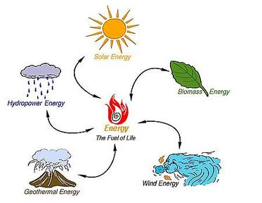
Apostrophe of Possession
Renewable and Non-Renewable Energy

Apostrophe of possession is used to show that the object belongs to someone or something. For example: Tom’s bicycle. The bicycle belongs to Tom. Or, the house’s roof needed repairing. The roof belongs to the house.

Choose the correct alternative:

1. The Sun’s/Suns energy are/is a renewable resource.

2. Renewable resource’s/resources can be replaced or used again and again.

3. The Earth’s/Earths water are/is a renewable resource.

4. Rock’s/rocks are considered a non-renewable resource. They are/is made from different minerals.

5. A rock’s/rocks minerals may be a very valuable resource.

6. The different soil’s/soils around the world are/is considered non-renewable resources.

7. A soil’s/soils composition makes it more or less useful for growing plants.

8. Beneath the Earth’s/Earths crust lies an renewable energy source known as geothermal energy.
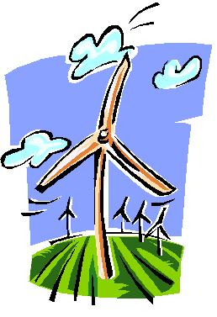

9. The wind’s/winds energy can be used to turn windmills and drive turbine’s/turbines to generate electricity.

